

PIMPRI CHINCHWAD EDUCATION TRUST's.
PIMPRI CHINCHWAD COLLEGE OF ENGINEERING
(An Autonomous Institute)

T.Y. B. TECH Year: 2025 – 26 Semester: VII
Name of the Student: Aryan Patil PRN: 124B2B004
Department: Computer Engineering Division: A
Course: Object Oriented Modelling and System Design

‘

OOM&D FA
1.Class Diagram
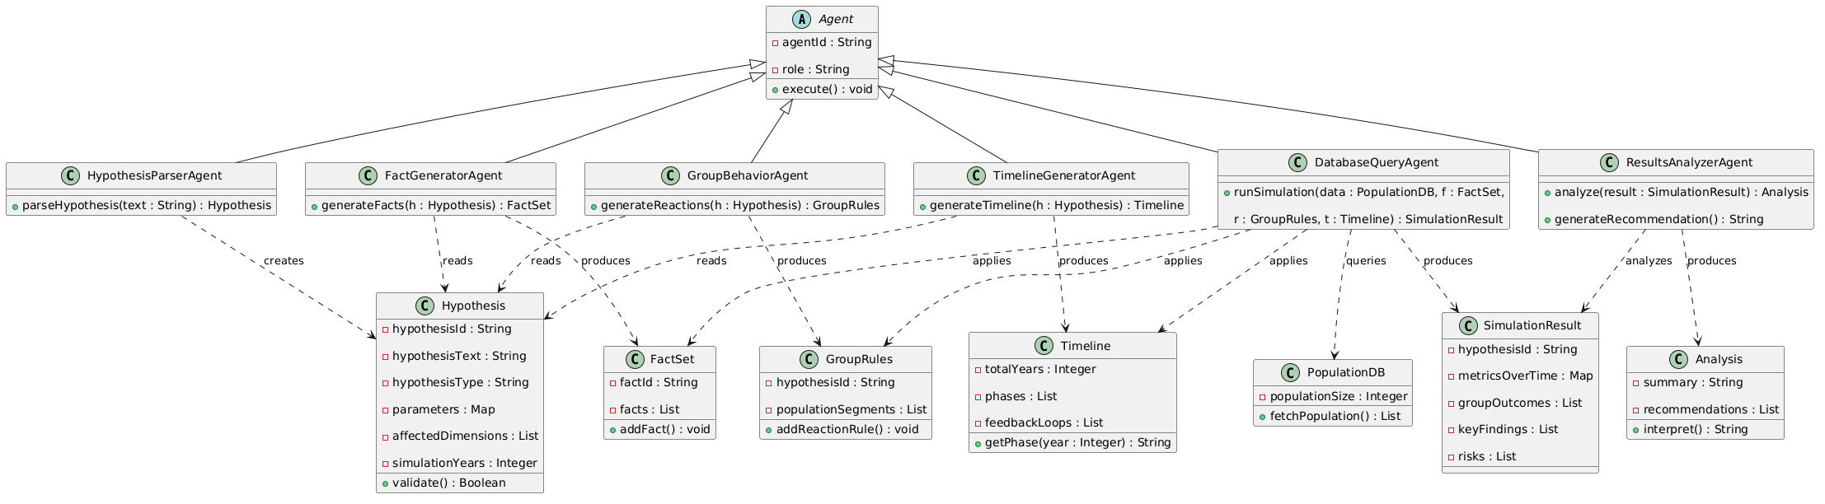
@startuml
abstract class Agent {
- agentId : String
- role : String
+ execute() : void
}
class HypothesisParserAgent {
+ parseHypothesis(text : String) : Hypothesis
}
class FactGeneratorAgent {
+ generateFacts(h : Hypothesis) : FactSet
}
class GroupBehaviorAgent {
+ generateReactions(h : Hypothesis) : GroupRules
}
class TimelineGeneratorAgent {
+ generateTimeline(h : Hypothesis) : Timeline
}
class DatabaseQueryAgent {
+ runSimulation(data : PopulationDB, f : FactSet,
r : GroupRules, t : Timeline) : SimulationResult
}
class ResultsAnalyzerAgent {
+ analyze(result : SimulationResult) : Analysis
+ generateRecommendation() : String
}
class Hypothesis {
- hypothesisId : String
- hypothesisText : String
- hypothesisType : String
- parameters : Map
- affectedDimensions : List
- simulationYears : Integer
+ validate() : Boolean
}
class FactSet {
- factId : String
- facts : List
+ addFact() : void
}
class GroupRules {
- hypothesisId : String
- populationSegments : List
+ addReactionRule() : void
}
class Timeline {
- totalYears : Integer
- phases : List
- feedbackLoops : List
+ getPhase(year : Integer) : String
}
class PopulationDB {
- populationSize : Integer
+ fetchPopulation() : List
}
class SimulationResult {
- hypothesisId : String
- metricsOverTime : Map
- groupOutcomes : List
- keyFindings : List
- risks : List
}
class Analysis {
- summary : String
- recommendations : List
+ interpret() : String
}
Agent <|-- HypothesisParserAgent
Agent <|-- FactGeneratorAgent
Agent <|-- GroupBehaviorAgent
Agent <|-- TimelineGeneratorAgent
Agent <|-- DatabaseQueryAgent
Agent <|-- ResultsAnalyzerAgent
HypothesisParserAgent ..> Hypothesis : creates
FactGeneratorAgent ..> Hypothesis : reads
FactGeneratorAgent ..> FactSet : produces
GroupBehaviorAgent ..> Hypothesis : reads
GroupBehaviorAgent ..> GroupRules : produces
TimelineGeneratorAgent ..> Hypothesis : reads
TimelineGeneratorAgent ..> Timeline : produces
DatabaseQueryAgent ..> PopulationDB : queries
DatabaseQueryAgent ..> FactSet : applies
DatabaseQueryAgent ..> GroupRules : applies
DatabaseQueryAgent ..> Timeline : applies
DatabaseQueryAgent ..> SimulationResult : produces
ResultsAnalyzerAgent ..> SimulationResult : analyzes
ResultsAnalyzerAgent ..> Analysis : produces
@enduml

2. Use Case Diagram
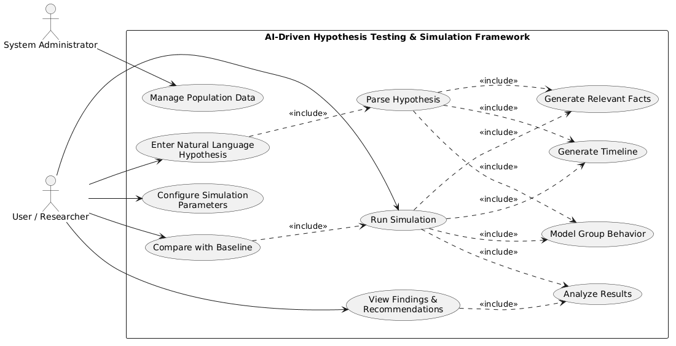

@startuml
left to right direction
actor "User / Researcher" as U
actor "System Administrator" as A
rectangle "AI-Driven Hypothesis Testing & Simulation Framework" {
usecase "Enter Natural Language\nHypothesis" as UC1
usecase "Configure Simulation\nParameters" as UC2
usecase "Parse Hypothesis" as UC3
usecase "Generate Relevant Facts" as UC4
usecase "Model Group Behavior" as UC5
usecase "Generate Timeline" as UC6
usecase "Run Simulation" as UC7
usecase "Analyze Results" as UC8
usecase "Compare with Baseline" as UC9
usecase "View Findings &\nRecommendations" as UC10
usecase "Manage Population Data" as UC11
}
U --> UC1
U --> UC2
U --> UC7
U --> UC9
U --> UC10
A --> UC11
UC1 ..> UC3 : <<include>>
UC3 ..> UC4 : <<include>>
UC3 ..> UC5 : <<include>>
UC3 ..> UC6 : <<include>>
UC7 ..> UC4 : <<include>>
UC7 ..> UC5 : <<include>>
UC7 ..> UC6 : <<include>>
UC7 ..> UC8 : <<include>>
UC9 ..> UC7 : <<include>>
UC10 ..> UC8 : <<include>>
@enduml

3. Sequence Diagram
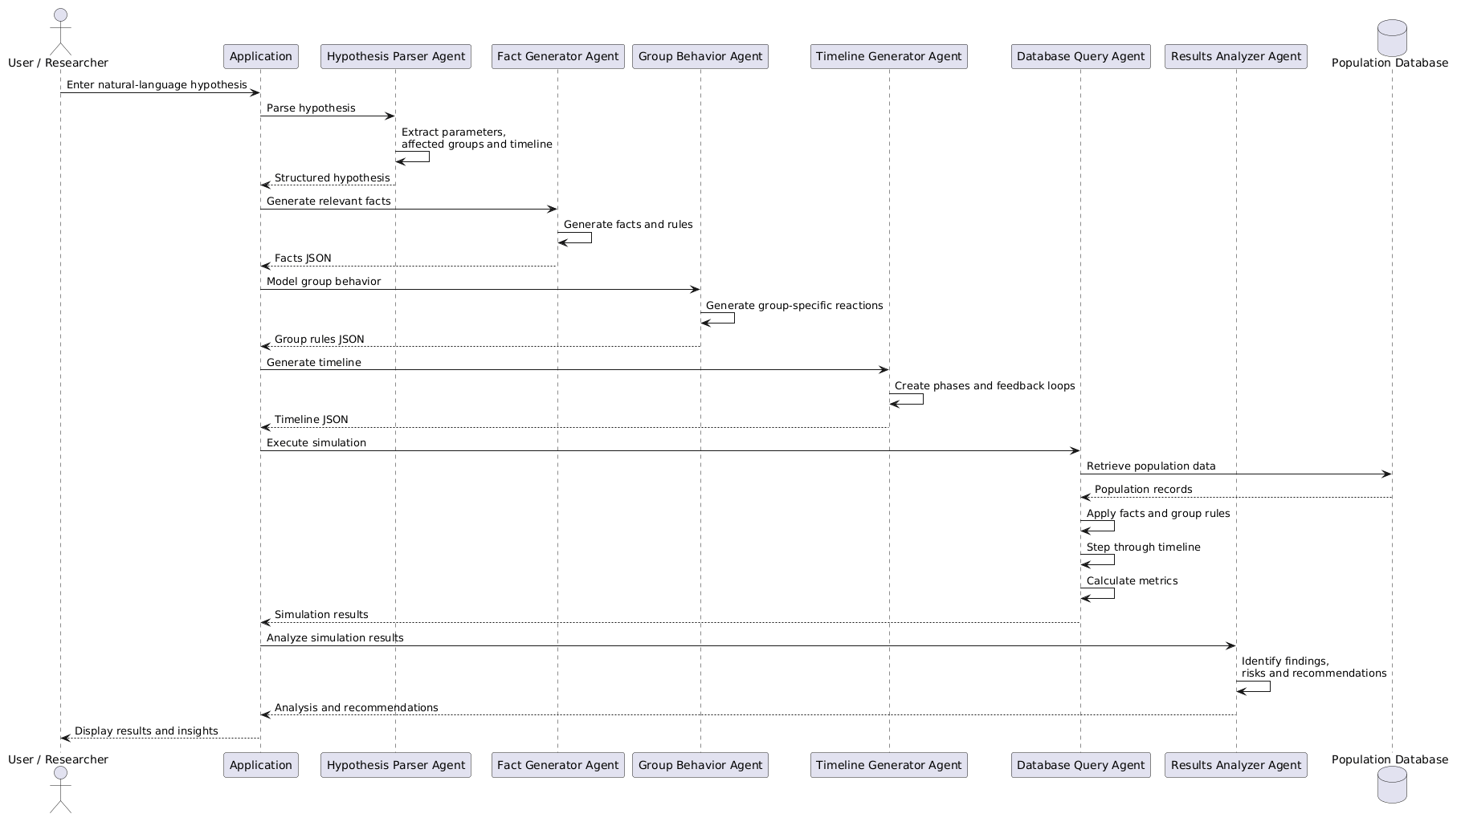

@startuml
actor "User / Researcher" as User
participant "Application" as App
participant "Hypothesis Parser Agent" as HPA
participant "Fact Generator Agent" as FGA
participant "Group Behavior Agent" as GBA
participant "Timeline Generator Agent" as TGA
participant "Database Query Agent" as DQA
participant "Results Analyzer Agent" as RAA
database "Population Database" as DB
User -> App : Enter natural-language hypothesis
App -> HPA : Parse hypothesis
HPA -> HPA : Extract parameters,\naffected groups and timeline
HPA --> App : Structured hypothesis
App -> FGA : Generate relevant facts
FGA -> FGA : Generate facts and rules
FGA --> App : Facts JSON
App -> GBA : Model group behavior
GBA -> GBA : Generate group-specific reactions
GBA --> App : Group rules JSON
App -> TGA : Generate timeline
TGA -> TGA : Create phases and feedback loops
TGA --> App : Timeline JSON
App -> DQA : Execute simulation
DQA -> DB : Retrieve population data
DB --> DQA : Population records
DQA -> DQA : Apply facts and group rules
DQA -> DQA : Step through timeline
DQA -> DQA : Calculate metrics
DQA --> App : Simulation results
App -> RAA : Analyze simulation results
RAA -> RAA : Identify findings,\nrisks and recommendations
RAA --> App : Analysis and recommendations
App --> User : Display results and insights
@enduml
4. Component Diagram
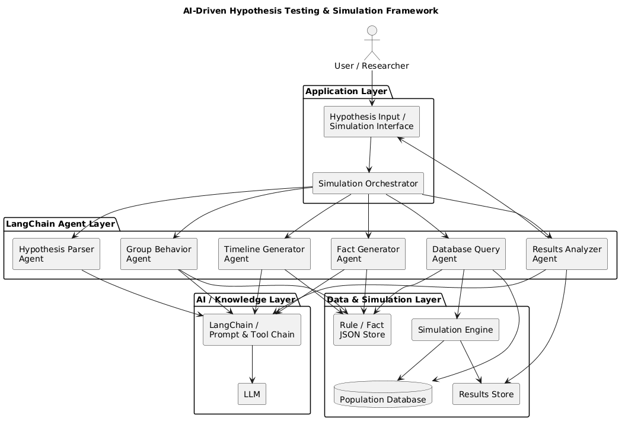
@startuml
title AI-Driven Hypothesis Testing & Simulation Framework
skinparam componentStyle rectangle
actor "User / Researcher" as User
package "Application Layer" {
component "Hypothesis Input /\nSimulation Interface" as UI
component "Simulation Orchestrator" as ORCH
}
package "LangChain Agent Layer" {
component "Hypothesis Parser\nAgent" as HPA
component "Fact Generator\nAgent" as FGA
component "Group Behavior\nAgent" as GBA
component "Timeline Generator\nAgent" as TGA
component "Database Query\nAgent" as DQA
component "Results Analyzer\nAgent" as RAA
}
package "AI / Knowledge Layer" {
component "LangChain /\nPrompt & Tool Chain" as LC
component "LLM" as LLM
}
package "Data & Simulation Layer" {
database "Population Database" as DB
component "Rule / Fact\nJSON Store" as FS
component "Simulation Engine" as SE
component "Results Store" as RS
}
User --> UI
UI --> ORCH
ORCH --> HPA
ORCH --> FGA
ORCH --> GBA
ORCH --> TGA
ORCH --> DQA
ORCH --> RAA
HPA --> LC
FGA --> LC
GBA --> LC
TGA --> LC
RAA --> LC
LC --> LLM
FGA --> FS
GBA --> FS
TGA --> FS
DQA --> DB
DQA --> FS
DQA --> SE
SE --> DB
SE --> RS
RAA --> RS
RAA --> UI
@enduml

